**Southern University of Science and Technology**

**Computer Networking Lab Report**

**唐润哲 11710418**

***Assignment 10.1***

* ***Description***

Initiates an ICMP session to test if www.example.com is reachable(setting the packet size is 3200B ), capture the packets.

1. How to initiate an ICMP Echo request with 3200B length?
2. Is there any fragmentation on the IP packets , how do you find it ?
3. How many fragments of a 3200B length IP packet ?
4. How do you identify the ICMP Echo request and Echo reply?
5. For the ICMP Echo request, which fragment is the 1st one, which is the last ? How do you identify them?
6. What’s the length of each IP fragment? Is the sum of eachfragment’s length equal to the original IP packet ?

* ***Result***

1. Command“ping -4 [www.example.com](http://www.example.com) -l 3200”is used to initiate an ICMP Echo request with 3200B length.
2. There is fragmentation on the IP packets, filter “icmp && !(ip.flags.mf eq 0)”is used to identify.
3. Three fragments are found.

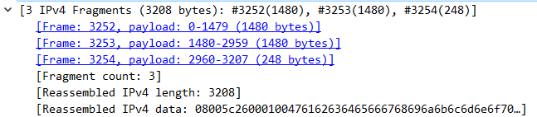

1. ICMP Echo request and Echo reply have different type number,8: Echo request,0: Echo reply. They are shown in the packet info.

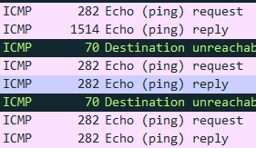

1. Identify them by the payload, the 1st and 2nd packet must be full and larger than or equal to the last packet, and the 3rd packet has the least data, so the Fragment #765 is the 1st one, Fragment #767 is the last one.

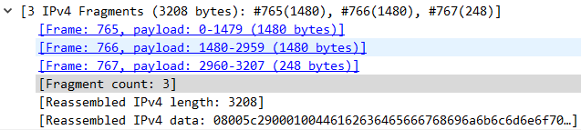

1. The length of each IP fragment is 1514+1514+282=3310. The length of original IP packet is 3200+20(IP header)+8(ICMP header)=3228. They are not equal.

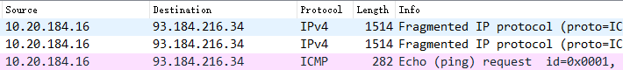

***Assignment 10.2***

* ***Description***

Using tracert (windows) / traceroute(linux or MacOS) to trace the route from your host to www.sustech.edu.cn,capture the packets while tracing

1. Is there any ‘Time-to-live exceeded’ ICMP packets ?
2. What’s the difference between these packets and normal ICMP packets(such as ICMP echo request)? List at least 3 aspects.

* ***Result***

1. 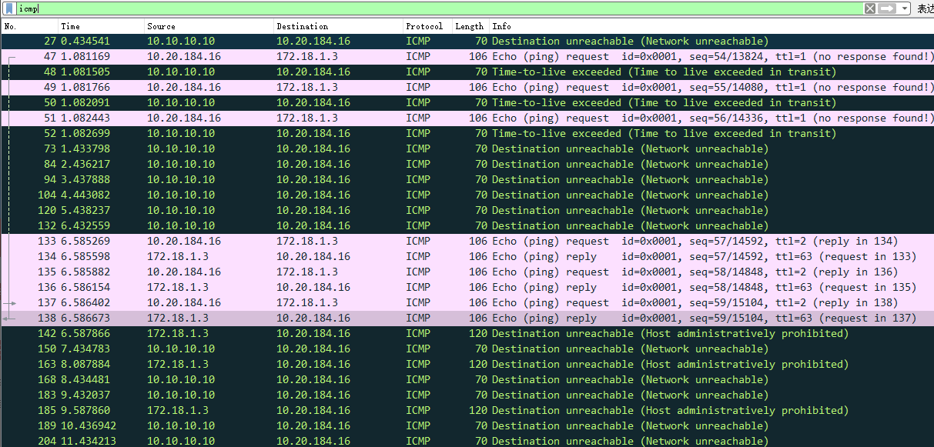There are serval “Time-to-live exceeded” ICMP packets
2. ①Their ICMP types are different，8 for normal,11 for ttl.

②The ttl packet includes a datagram from the ttl router/terminal.

③The normal packet has Data(64 bytes)

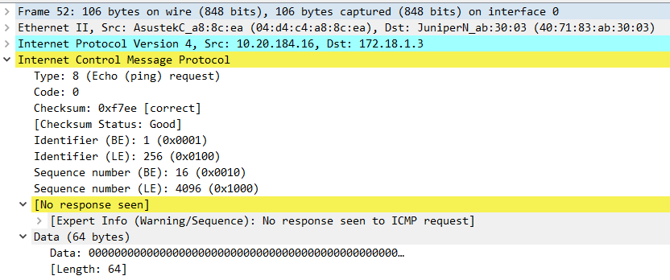

***normal ICMP packet***

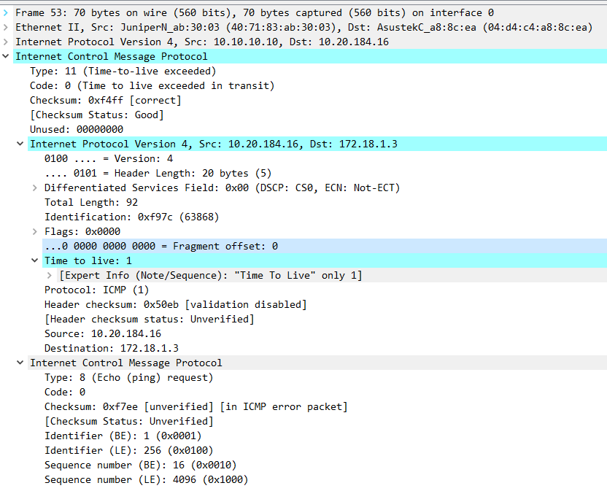

***TTL-exceeded ICMP packet***

***Assignment 10.3***

* ***Description***

Initiates a DHCP session

1. How to initiate a DHCP session? How to find the DHCP session packets?
2. What ‘s the source IP address and destination IP address of a DHCP request? What is the type of these two IP address?
3. What info items are required for a host if it need to contact with others in the Internet?
4. How do you find the Lease Time of a dynamic IP address? What’s the value of it? In which type of DHCP packet could this field be set?

* ***Result***

1. 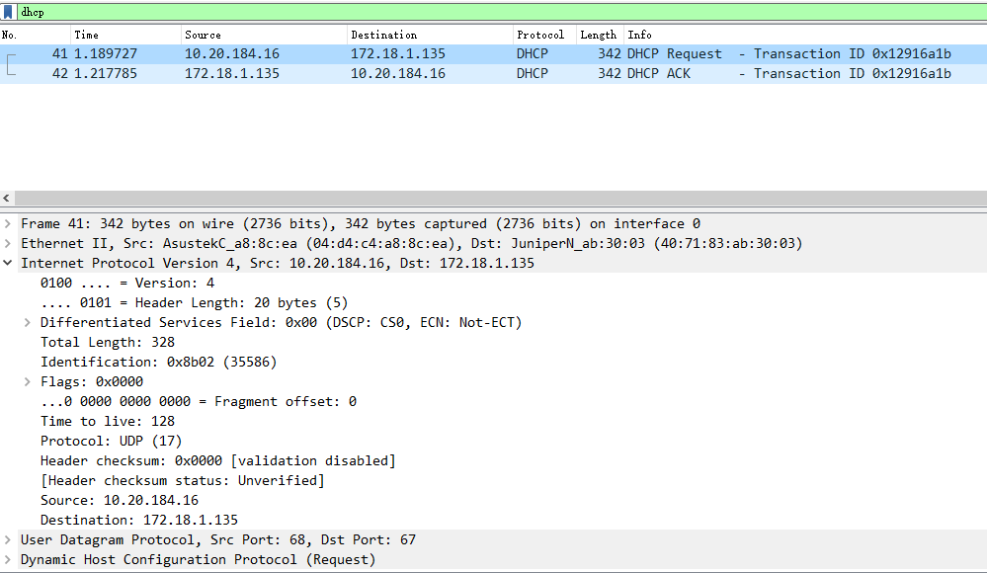Command“ipconfig -renew”is used to initiate a DHCP session. Filter “dhcp” is used.
2. Source IP address :

0.0.0.0 non-routable meta-address

Destination IP address:

255.255.255.255 broadcast address

1. Option: (55) includes all info items required.

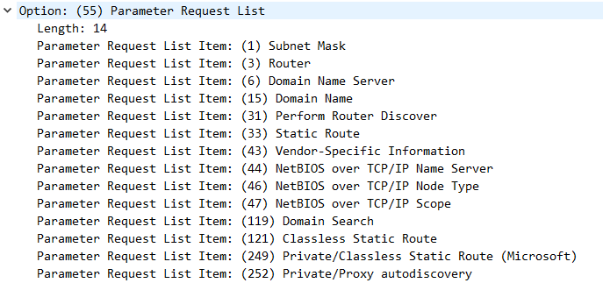

1. Option: (51) IP Address Least Time.

The value is 172800s=2days.

Offer packet set the field.

